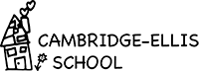

Preschool Teacher

French Immersion Program

2018 School Year
Cambridge-Ellis School is hiring a preschool teacher for our French Immersion Preschool Classroom for the 2018-19 school year.

Preschool teaching experience required, MA EEC teacher certification is preferable.

Cambridge-Ellis School is a diverse preschool community with a strong emphasis on nature and arts experiences. Teams teach with highly experienced preschool educators.

Send resume and cover letter to suzi@cambridge-ellis.org .

PLEASE POST!

